Checkendon Equestrian Centre
Lovegrove's Lane, Checkendon RG8 ONE
www.checkendonequestrian.co.uk

FREE INVITATION TO RIDE
HENRY THE MECHANICAL HORSE

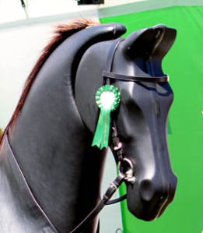
Checkendon Equestrian Centre, in association with Sport England and The British Equestrian Federation’s Olympic Legacy “Hoof” programme, which aims to help more people to discover horses, get fit and improve their wellbeing, invites you to come and ride Henry.

This is the chance for new or lapsed riders to experience life in the saddle at walk, trot, canter in a highly safe, stationary and controlled environment – suitable for adults and children over eight years old.

Henry will be stabled with us for one week only from:
Saturday 26th - Thursday 1st May 2014 (excluding 28th April).

Please email Linda at linda@checkendonequestrian.co.uk
or call 01491 680-225 to book your free place.

